Practical 02

Code :- # Strings

string = "Hello, World!"

# Creation print(string)

# Indexing print(string[0]) print(string[-1])

# Slicing print(string[2:5]) print(string[:3]) print(string[6:])

# Concatenation

new_string = string + " How are you?" print(new_string)

# Repetition repeated_string = string * 3 print(repeated_string)

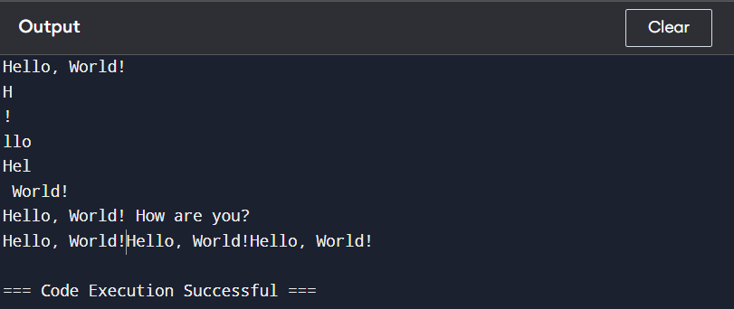

# Lists

numbers = [1, 2, 3, 4, 5]

# Creation print(numbers)

# Indexing print(numbers[0]) print(numbers[-1])

# Slicing print(numbers[2:4]) print(numbers[:3]) print(numbers[3:])

# Concatenation

new_numbers = numbers + [6, 7] print(new_numbers)

# Repetition

repeated_numbers = numbers * 2 print(repeated_numbers)

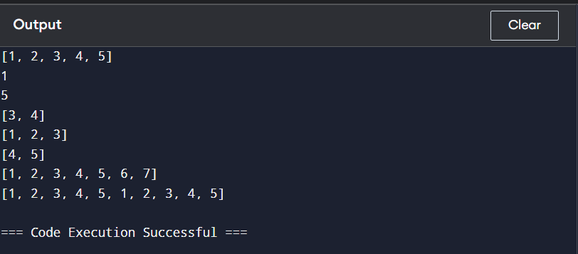

# Tuples

fruits = ("apple", "banana", "orange")

# Creation print(fruits)

# Indexing print(fruits[0]) print(fruits[-1])

# Slicing print(fruits[1:3])

# Concatenation

new_fruits = fruits + ("grape",) print(new_fruits)

# Repetition repeated_fruits = fruits * 2 print(repeated_fruits)

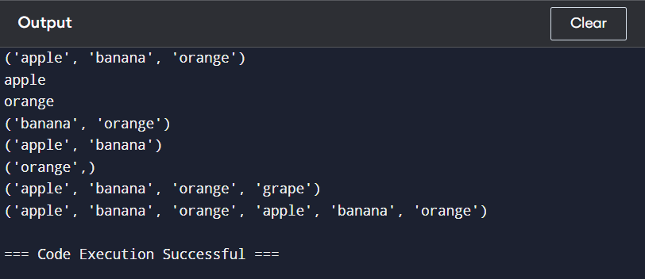

# Dictionaries

person = {"name": "Alice", "age": 30, "city": "New York"}

# Creation print(person)

# Accessing values print(person["name"]) print(person.get("age"))

# Adding/modifying values person["occupation"] = "Engineer" print(person)

# Deleting values del person["city"] print(person)

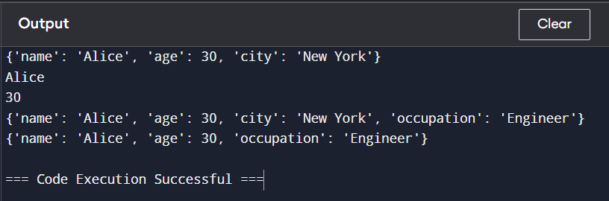

# Sets

numbers_set = {1, 2, 3, 4, 5}

# Creation print(numbers_set)

# Adding elements numbers_set.add(6) print(numbers_set)

# Removing elements numbers_set.remove(3) print(numbers_set)

# Union of sets set1 = {1, 2, 3}

set2 = {3, 4, 5}

union_set = set1 | set2 print(union_set)

# Intersection of sets intersection_set = set1 & set2 print(intersection_set)

